Unreadable IC labels
https://electronics.stackexchange.com/questions/5186/how-to-read-the-text-printed-on-top-of-every-ic

White marker
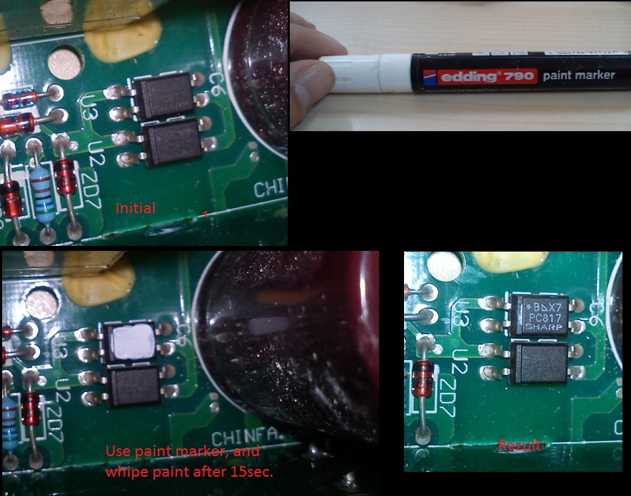

Chalk
1. Clean up the text with a cotton swab dipped in rubbing alcohol.
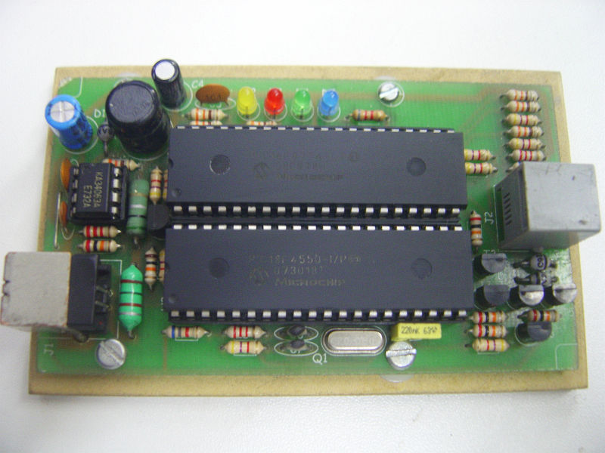
2. Wait for the alcohol to evaporate and rub yellow or white chalk on markings.
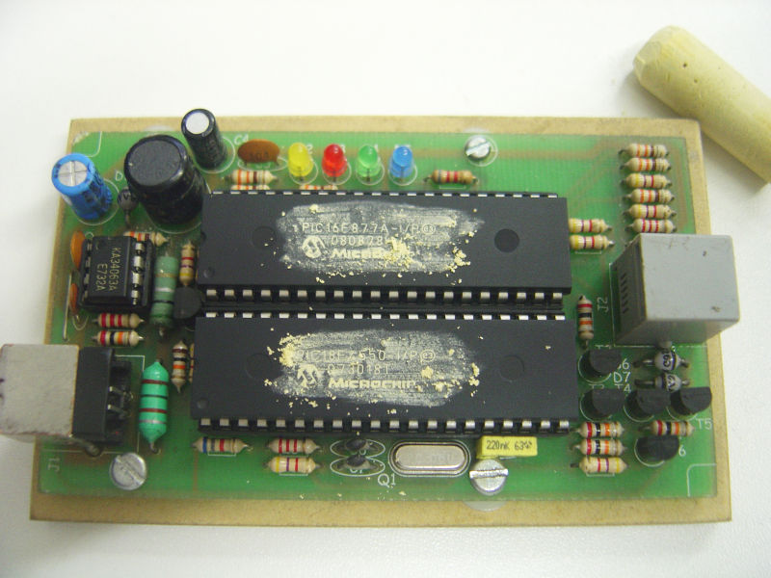
3. Wipe gently with a cotton swab and bingo!


