Operační zesilovače

Unity gain, audio, asymetrical supply
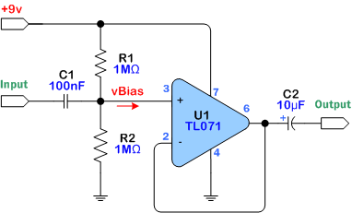

3 band tone correction audio equalizer

