Battery Desulphator
This device is claimed to revive various kinds of old and dead batteries using constant pulsed current.

Initial design
- http://screwdecaf.cx/dapimp.html
- http://hackaday.com/2012/05/19/geeks-living-off-the-grid-are-hard-on-batteries/
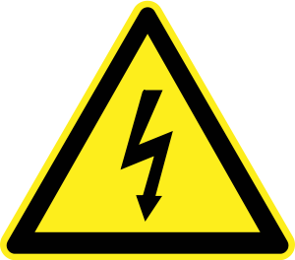

Shock hazard! All of these circuits can have like 600V on it's outputs at any time during operation. Please take extreme caution when handling this. There is no transformer, which means device and your batteries are directly coupled to mains AC power. Disconnect whole device from AC before touching any of terminals or batteries (including electrolyte) as switches may fail shorted. Use 1:1 laboratory isolation transformer if you can. See Rechargeable Batteries page for informations on battery voltage limits.

My improvements
I am experimenting with several design modifications to provide better pulses to desulphate batteries.

Half-bridge mode
Half bridge modification can provide more time between pulses, so battery has more time to revive… Note that resistor in following schematic is used as placeholder instead of actual battery for simulation purposes: 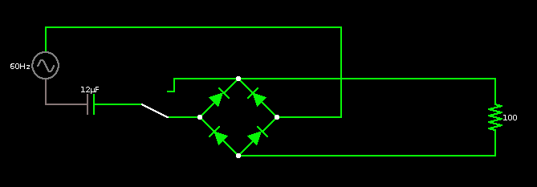
Current through battery as captured using soundcard and shunt resistor (half bridge on the left, full bridge on the right): 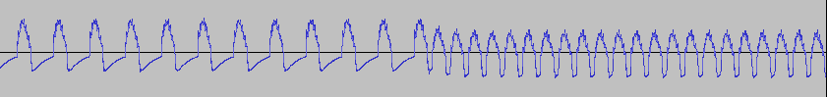
Note that you will probably want to double the capacitors in this mode to achieve same current as with full-bridge.

Spike generator
This mod makes charger use high voltage pulses (while RMS current is kept constant). It uses SCR (or TRIAC) triggered by high voltage zener diode (or transil) to generate pulse when voltage rises enough. I reccomend to use zener diode or transil (doesn't matter if uni/bi-directional) with zener voltage slightly below maximal voltage in your country (=circa RMS voltage * 1.4).
Here is schematic with simulation (classic half-bridge mode on the left, half-bridge combined with triac spike trigger on the right): 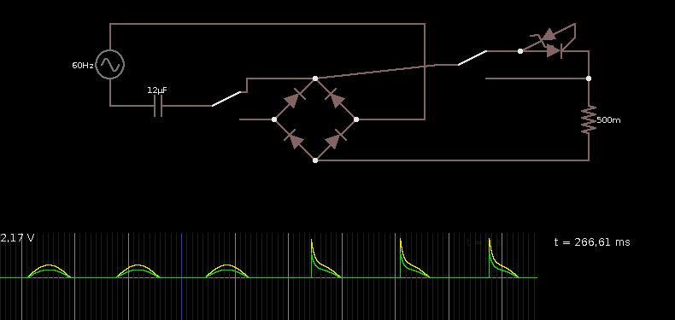
Here is current as captured by soundcard using shunt:

However in fact this circuit has terrible PFC correction and is quite noisy because of the spikes and in actual operation it produces unwanted effects (both audible and electromagnetic). So maybe we should also add some chokes at the AC input to provide filtering (+some small chokes at the caps to make spikes just little bit less sharp).
Also the triac gets bit warm after a while without cooling. It's still OK to touch (plug device off before trying!!!), but adding some small heatsink may be desirable…

Filters
I've had problems with switches/relays having it's contacts welded together. I've found that putting small chokes rated for enough current in series with such switches will limit current rushes caused by capacitors and prevent contact welding in most cases.

Results
- 18V Ni-Cd - I've been able to restore battery pack from cordless drill to some point. I've discharged it first and then let the leads shorted for few hours to provide deep discharge. Then i've been charging it for hour or few like once a day or two. Made sure that it never climbed over 23.2V. Now it seems "better". Drill keeps running for more than 5 seconds without getting imediately depleted. Not tested it completely yet. Maybe another discharge/charge cycle may be vital…

